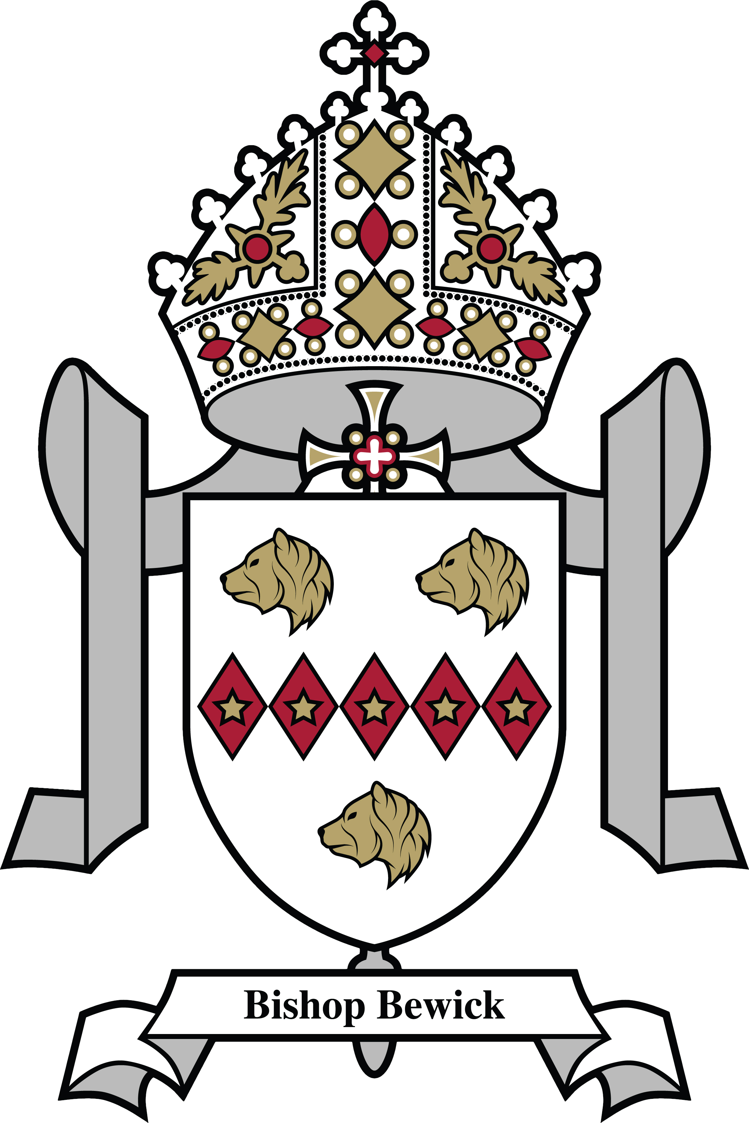
DIOCESE OF HEXHAM AND NEWCASTLE
SAINT CUTHBERT’S CATHOLIC FIRST SCHOOL
SUPPLEMENTARY INFORMATION FORM 2024/2025
If you are expressing a preference for a place for your child at St Cuthbert’s Catholic First School in Northumberland and wish to apply under a faith criterion, you should complete this Supplementary Information Form.
• The completed Supplementary Information Form, together with all supporting documentation (see Notes below), should be returned in an envelope to Mrs Barbara Simpson (Chair of Governors) at the school by the closing date: 15 January 2024
• If you do not provide the information required in this form and return it to the school, with all supporting documentation (e.g. Baptism certificate) by the closing date, your child may not be placed in the appropriate faith category.
• Remember – you must also complete the Common Application Form online at www.northumberland.gov.uk

Name of child: _______________________________________________________________________
Address of child: ____________________________________________________________________________________
______________________________________ ______________________________________________
Parent/Carer Details
Parent/Carer Name: _____________________________________________
Parent/Carer Address: (if different from above) _____________________________________________
______________________________________ ______________________________________________
Names of siblings attending St Cuthbert’s Catholic First School in September 2024
____________________________________________________________________________________

Please read our school Admission Policy (available on the school website), noting in particular any faith criteria, and your Local Authority booklet, before completing this form.
NOTE: When completing the Common Application Form, it is important that you provide details of any siblings (brothers or sisters) who will be attending this school at the proposed time of admission. If this information is not provided the admission authority of this school may not be able to place the application within the correct criteria.
PTO
Religious Status of child (please indicate by placing a tick in the appropriate box – please note that a tick should be indicated in only a single box) Criteria Tick Box Evidence [insert details in accordance with the Notes below]
Criteria | Tick box | Evidence
- Catholic children who are resident in the parish of Our Lady & St Cuthbert’s (see note 1)
- Catechumens (see note 2)

- Eastern Christian Church (see notes 3)

- Children of other Christian denominations (see note 4)

- Children of other faiths (see note 5)

Catholic [Parish] [Deanery] in which your child lives:

NOTES AND DEFINITIONS
- Catholic means a member of a Church in full communion with the See of Rome. This includes the Eastern Catholic Churches. This will be evidenced by a certificate of baptism in a Catholic Church or a certificate of reception into the full communion of the Catholic Church. Those who have difficulty obtaining written evidence of baptism or reception should contact their parish priest who, after consulting with the Diocese, will decide how the question of baptism or reception is to be resolved and how written evidence is to be produced in accordance with the law of the Church.

- Catechumen means a member of the catechumenate of a Catholic Church. For the purposes of admissions this refers to the child on whose behalf the application is being made. This will normally be evidenced by a certificate of reception into the order of catechumens.

- Eastern Christian Church includes Orthodox Churches, and is normally evidenced by a certificate of baptism or reception from the authorities of that Church. Those who have difficulty obtaining written evidence of baptism or reception should contact the Diocese who will decide how the question of baptism or reception is to be resolved and how written evidence is to be produced in accordance with the law of the Church.

- Children of other Christian denominations means children who belong to other churches and ecclesial communities which, acknowledge God’s revelation in Christ, confess the Lord Jesus Christ as God and Saviour according to the Scriptures, and, in obedience to God’s will and in the power of the Holy Spirit commit themselves: to seek a deepening of their communion with Christ and with one another in the Church, which is his body; and to fulfil their mission to proclaim the Gospel by common witness and service in the world to the glory of the one God, Father, Son and Holy Spirit. An ecclesial community which on principle has no credal statements in its tradition, is included if it manifests faith in Christ as witnessed to in the Scriptures and is committed to working in the spirit of the above.

All members of Churches Together in England and CYTÛN are deemed to be included in the above definition, as are all other churches and ecclesial communities that are in membership of any local Churches Together Group (by whatever title) on the above basis.

Applicants must provide a baptismal certificate or where child baptism is not practised, a letter confirming their church membership from their minister or faith leader.

- Children of other faiths means children who are members of a religious community that does not fall within the definition of ‘other Christian denominations’ at 6 above and which falls within the definition of a religion for the purposes of charity law. The Charities Act 2011 defines religion to include:

- A religion which involves belief in more than one God, and
- A religion which does not involve belief in a God.

Case law has identified certain characteristics which describe the meaning of religion for the purposes of charity law, which are characterised by a belief in a supreme being and an expression of belief in that supreme being through worship.

Applicants must provide a letter of support to confirm their faith membership from their minister or faith leader.

