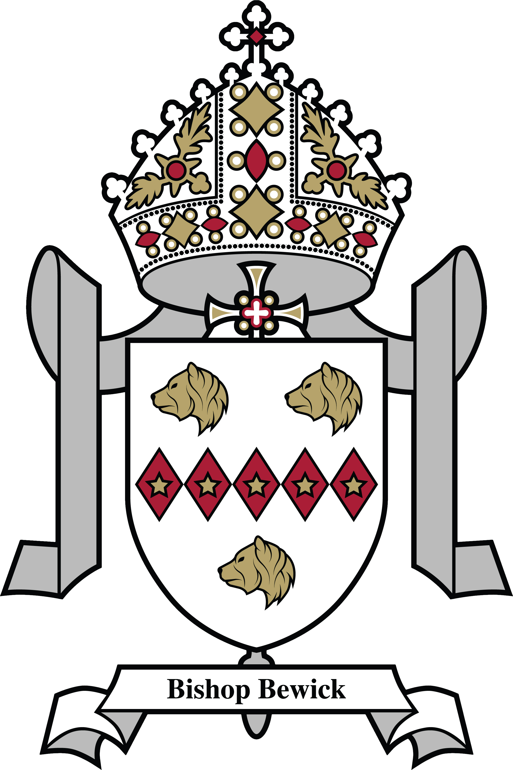
St Cuthbert’s Catholic First School
SCHOOL TERM DATES 2023 – 24

AUTUMN TERM  School holiday | Monday 4 September & Tuesday 5 September Training days – To be confirmed  Wednesday 6 September – Friday 20 October  Monday 30 October – Friday 3 November
School holiday | Monday 30 October – Friday 22 December  Monday 25 December – Friday 5 January
SPRING TERM  School holiday | Monday 8 January Training day – To be confirmed  Tuesday 9 January – Friday 9 February  Monday 19 February – Friday 23 February
School holiday | Monday 19 February – Thursday 28 March  Friday 29 March – Friday 12 April  (Easter weekend 29 March – 1 April)
SUMMER TERM  School holiday | Monday 15 April – Friday 24 May  (May Day Bank holiday will be taken 6 May  Monday 27 May – Friday 31 May  (Spring Bank holiday will be taken 27 May)
 | Monday 3 June – Friday 19th July

Public Holidays
Christmas Day | Monday 25 December 2023
Boxing Day | Tuesday 26 December 2023
New Year’s Day | Monday 1 January 2024
Good Friday | Friday 29 March 2024
Easter Monday | Monday 1 April 2024
May Day Bank Holiday | Monday 6 May 2024
Spring Bank Holiday | Monday 27 May 2024
August Bank Holiday | Monday 26 August 2024

The new school year (2024-25) will begin on Monday 2 September 2024.

